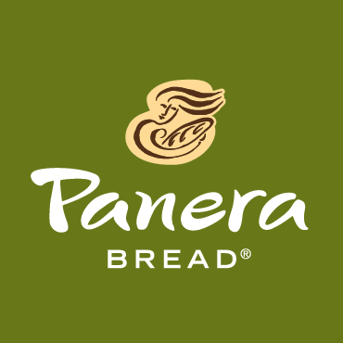
Ashlee Mauti
Covelli Enterprises
Ashlee.Mauti@covelli.om
412-445-1884
FOR IMMEDIATE RELEASE

COVELLI ENTERPRISES AND PANERA BREAD HELP RAISE MONEY
FOR THE RICH CENTER FOR AUTISM AT YSU AND POTENTIAL DEVELOPMENT
Puzzle piece cookies to be sold April 9-15 with 100% of the proceeds benefitting two charities #everycookiecounts

Warren, OH, March 31, 2017 – In keeping with its long standing commitment of giving back to the community, Covelli Enterprises is partnering with The Rich Center for Autism at YSU and Potential Development during Autism Awareness month to raise money for programs that help families in the Valley.

Beginning Monday, April 9 through Sunday, April 15, 100% of the proceeds from all ‘Pieces of Hope’ cookie sales will be donated to The Rich Center and Potential Development. The puzzle piece cookie, designed by the Covelli bakers, is the national symbol for autism because of the complexity of the Autism Spectrum Disorder. Because all puzzle pieces are different, the shape represents the diversity of those affected. The ‘Pieces of Hope’ puzzle piece cookies will be sold in all cafes in the Mahoning Valley and Hermitage, PA.
Throughout the month of April, Panera Bread will also be collecting Community Breadbox donations at the registers of all of its local cafés to raise additional funds for both schools as part of its Covelli Cares community support.

“We are honored to a part of the Pieces of Hope Campaign to benefit Potential Development Schools for Students with Autism and the Rich Center for Autism. The campaign will help us celebrate Autism Awareness Month as well as ensure students with Autism achieve their greatest potential and lead an independent life,” said Paul Garchar, Executive Director of Potential Development School for Students with Autism.

Melanie Carfolo, Executive Director of The Rich Center for Autism at YSU said, “The Rich Center for Autism is honored to once again be chosen by Covelli Enterprises as their charity of choice to receive proceeds from the Panera Bread Pieces of Hope Cookie Sale. The generosity of community partners, like Covelli Enterprises, as well as other Valley residents is quite humbling, and makes it possible for The Rich Center to provide tuition-free, year-round therapy, education and support to families of children with autism.”

Over the past 7 years the Pieces of Hope cookie campaign has raised over $1.4 million in Covelli-owned Panera Bread locations and $120,000 here in the Valley.

Sam Covelli, CEO of Covelli Enterprises, the owner and operator of Panera Bread cafes locally, said he is honored that his restaurants can help raise funds and awareness for autism. He said he also has a deep appreciation for the work that is done at The Rich Center and Potential Development. “I love our ‘Pieces of Hope for Autism’ campaign because I know how much good it is doing in our communities,” said Sam Covelli, Owner/Operator of Covelli Enterprises. “This special cookie has allowed us to make such a positive difference for those with autism here in our Valley, and that’s something we are extremely proud of.”

About The Rich Center for Autism at Youngstown State University
The Rich Center for Autism was established in 1995 by the Rubino, Ricchiuti, and Kosar families to improve the conditions with which children with autism learn to live. Current statistics show that autism affects 1 in 68 children and 1 in 42 boys. By combining current research about autism with the newest and most innovative theories in education, The Rich Center for Autism offers hope that children affected with autism can reach their full potential. Therefore, the primary emphasis is on teaching and research as well as focusing on the intensive training to children with autism. As a tuition-free center, The Rich Center for Autism does not receive any monies from our families for operating expenses. The Rich Center relies on private donations, grants, and fundraising events to bridge the gap between State of Ohio Autism Scholarship payments and operating expenses. For more information about programs and services offered at The Rich Center for Autism, please visit www.richcenter.org.

About Potential Development
Potential Development provides children with autism, preschool through high school graduation, a safe, structured educational environment with caring, supportive services that give our students the necessary skills and independence to lead a productive life.

About Covelli Enterprises
Covelli Enterprises operates more than 300 Panera Bread bakery-cafés in eight states. Headquartered in Warren, Ohio, Covelli Enterprises is the single largest franchisee of Panera Bread, LLC. In 2017, Covelli Enterprises donated more than $32 million to hunger relief agencies and non-profit organizations through Covelli Cares. www.covelli.com www.covelli/autism
###

