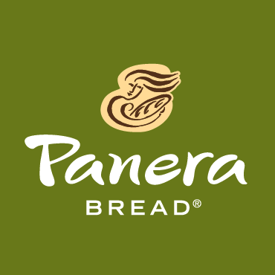
Liz Fiorino
Covelli Enterprises
6693 Sawmill Road
Dublin, OH 43017
Liz.Fiorino@covelli.com
412-310-3323
FOR IMMEDIATE RELEASE

PANERA BREAD DONATES $1,000 TO THE UNITED WAY OF MUSKINGUM, PERRY AND MORGAN COUNTIES AT RIBBON CUTTING CEREMONY FRIDAY
Donation made in honor of new Panera Bread café in Zanesville

June 3, 2016 - Ohio-based Covelli Enterprises, the largest franchisee of Panera Bread, donated $1,000 to the United Way of Muskingum, Perry and Morgan Counties Friday as part of the official Ribbon Cutting Ceremony for their newest Panera Bread bakery-café in Zanesville.

The new Panera Bread café location officially opened on Tuesday, May 17 at 3780 Frazeysburg Road near Mattress Firm. The Grand Opening included several days of special offers and a two-week fundraising promotion benefitting the United Way. For every $5 gift card redeemed at the new location, Panera Bread donated $1 to the cause. The new Panera Bread also collected funds in canisters at its registers for the United Way.

The Ribbon Cutting was held at 10am with a VIP reception immediately following. Mayor Jeff Tilton made remarks. Representatives from the Zanesville Chamber of Commerce assisted with the cutting of the ribbon. Meg Deedrick of the United Way was present to accept the check on behalf of the charity.

The new Zanesville location was one of the most successful Panera Bread café openings in all of Central Ohio. The café will continue to support the local United Way through its collection canisters located at the registers.

About Covelli Enterprises
Covelli Enterprises is the single largest franchisee of Panera Bread with more than 300 bakery-cafes in Ohio, Pennsylvania, West Virginia, Kentucky, Canada, and Florida. The company prides itself on giving back to the communities it serves, donating $26 million to charity in 2015 alone. www.covelli.com

###

