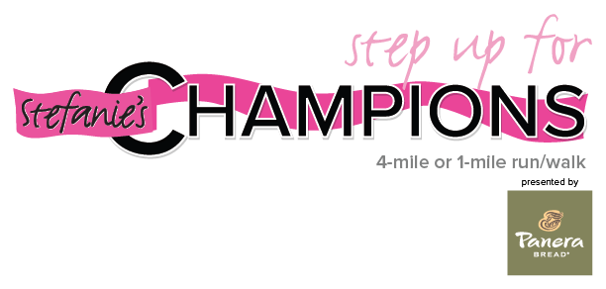
The James, Covelli Enterprises Announce Return of Annual
Spielman Fund Walk/Run

[COLUMBUS, OH] — November 13, 2015— The Ohio State University Comprehensive Cancer Center –Arthur G. James Cancer Hospital and Richard J. Solove Research Institute (OSUCCC – James) along with Covelli Enterprises, the largest franchisee of Panera Bread, are proud to announce the much-anticipated return of a beloved event benefiting the Stefanie Spielman Fund for Breast Cancer Research at the OSUCCC – James. The Step Up for Stefanie’s Champions Walk/Run (formerly known as Step Up for Stefanie) will be held on Saturday, April 23, 2016 in Columbus. The event hosted more than 4,000 participants in its inaugural year back in 2011.

Stefanie’s Champions began as a luncheon event in 2000 when Stefanie Spielman presented husband Chris Spielman with the first Champion Award, created to recognize those who have played a significant role in the lives of cancer survivors. Over the last 15 years, Stefanie’s Champions has raised more than $1.7 million for the Spielman Fund. Cancer survivors can nominate their champions for the 2016 Champion awards at SpielmanFund.com.

“Stefanie believed in changing and evolving to further her message of hope and inspiration with a greater audience,” says Chris Spielman, co-founder of the Spielman Fund, former OSU and NFL linebacker, and current ESPN analyst. “Bringing together the Stefanie’s Champions and Step Up for Stefanie events will allow us to bring the community together in a new way, furthering our efforts to create a cancer-free world and Stef’s mission to continue the fight against breast cancer.”

The event will consist of both a 4-mile and 1-mile walk/run, and will start and end at the Stefanie Spielman Comprehensive Breast Center at 1145 Olentangy River Road.

During its first three years, Covelli Enterprises underwrote 100% of the cost to host the race, and the company is proud to return as the Presenting Sponsor of Step Up for Stefanie’s Champions.

Since 2011, Covelli Enterprises has raised more than $600,000 for the Spielman Fund to support life-saving research happening at the OSUCCC – James. This past October, Central Ohio Panera Bread bakery-cafes sold nearly 47,000 Pink Ribbon Bagels to help benefit the cause.

“We couldn’t be more excited to see the Step Up event return in 2016,” said Sam Covelli, Owner/Operator of Covelli Enterprises. “We’ve been so proud to support The Stefanie Spielman Fund over the years knowing that our dollars are translating to lives saved at The James and around the country. This is truly a cause this entire community rallies around, and we can’t wait to see everyone lining up on April 23 to help make a difference!”

Information can be found at www.spielmanfund.com. Registration is now open and exciting sponsorship opportunities are available.
Registration Fees
Regular participants:
- $36 until December 31, 2015
- $45 January 1 – March 31, 2016
- $55 after April 1, 2016
Ohio State Student Pricing:
- $25 until December 31, 2015
- $35 January 1 – March 31, 2016
- $40 after April 1, 2016

About The OSUCCC – James
The Ohio State University Comprehensive Cancer Center – Arthur G. James Cancer Hospital and Richard J. Solove Research Institute strives to create a cancer-free world by integrating scientific research with excellence in education and patient-centered care, a strategy that leads to better methods of prevention, detection and treatment. Ohio State is one of only 44 National Cancer Institute-designated Comprehensive Cancer Centers and one of only four centers funded by the NCI to conduct both phase I and phase II clinical trials on novel anticancer drugs. As the cancer program’s 306-bed adult patient-care component, The James is one of the top cancer hospitals in the nation as ranked by U.S. News & World Report and has achieved Magnet designation, the highest honor an organization can receive for quality patient care and professional nursing practice. At 21 floors with more than 1.1 million square feet, The James is a transformational facility that fosters collaboration and integration of cancer research and clinical cancer care. For more information, please visit cancer.osu.edu.

About Covelli Enterprises
Headquartered in Ohio, Covelli Enterprises, is the largest franchisee of Panera Bread with more than 270 Panera Bread cafes in Ohio, Pennsylvania, West Virginia, Kentucky, Florida and Toronto, Canada. In 2014 alone, Covelli Enterprises donated more than $23 million to charity. www.covelli.com

###

