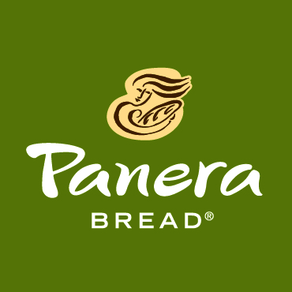
Liz Fiorino
Covelli Enterprises
6693 Sawmill Road
Dublin, OH 43017
Liz.fiorino@covelli.com
412-310-3323
FOR IMMEDIATE RELEASE

PANERA BREAD LAUNCHES
SMALL ORDER DELIVERY NEAR CAMPUS
Launch signals more Panera 2.0 changes ahead for Columbus market

COLUMBUS, OH, August 23, 2016 – Covelli Enterprises, the Ohio-based franchisee of Panera Bread, announced Tuesday the launch of small order delivery at its Panera Bread café at 300 W. Lane Avenue on OSU’s campus. The launch is the first of many changes being implemented as part of Panera 2.0, the concept’s vision for improving the customer experience through the use of technology.

Panera delivery offers customers the ability to place a single order online and have it delivered directly to them as long as they are within our designated delivery radius. The Lane Avenue café will deliver to any location within an 8-minute drive.

This delivery service launched in Dayton in June and has resulted in tremendous growth in sales volume to the Dayton Panera cafés. The business from delivery is 80% incremental, which means the service is reaching an entirely new audience for Panera. Delivery allows customers who may be unable to leave their workplaces to visit a café for lunch, for example hospital employees or teachers, to enjoy the Panera experience from where they are. The delivery option is expected to also be popular with college students, as this service will deliver to both dorms and off-campus housing.

"We are so pleased to able to offer delivery to our friends on OSU’s campus and in the surrounding areas. We hope to be able to reach new customers but also offer this incredibly convenient service to our existing loyal customers unable to make it to the bakery café on a regular basis,” said Sam Covelli, Owner and CEO Covelli Enterprises. “Our goal is to make Panera as accessible as it is craveable.”

Delivery requires a minimum order of only $5.00 with the addition of a $3.00 deliver charge. All delivery orders are currently placed online (credit card only) using the Panera Bread app or at panerabread.com. Hours of delivery service are set for 11:00 am - 8:00 pm., meaning the first delivery order can be placed at 10:30 am and the last at 7:30 pm. Panera will deliver anywhere within the delivery radius, not just to people's places of work. Customers often use Panera delivery for lunch deliveries to their place of work and dinner deliveries to their homes.

Small order delivery is just one of the new services being rolled out in local Panera Bread cafes. This August, several Panera cafés in Columbus launched fast lane kiosks that allow customers to place their in-café order themselves at digital kiosks instead of visiting a cashier. Kiosks encourage customization and increase order accuracy since the customers input their own orders. These kiosks, however, will not replace any human labor within the cafés. Panera has reallocated positions within the café to support order accuracy on the line and overall customer satisfaction with food and service.

The kiosks are already in place at all 3 Panera café locations on OSU’s campus. They will launch by the end of the month in the area’s fourth Panera 2.0 location at 555 South State Street in Westerville. The market plans to roll out both fast lane kiosks and small order delivery to the rest of the Columbus market in early 2017.

The Lane Avenue cafe will likely hire up to 16 Delivery Team Members (DTMs) to cover the volume of orders it expects will be added by delivery on and near campus. The DTM's primary position is delivering orders, but he/she will also be certified in non-service positions to work while not driving. Positions are still available. Interested prospective DTMs may apply in-café or online at panerabread.jobs.

About Covelli Enterprises
Covelli Enterprises operates more than 300 Panera Bread bakery-cafés in the U.S. and Ontario, Canada. Headquartered in Warren, Ohio, Covelli Enterprises is the nation’s largest franchisee of Panera Bread, LLC. Covelli Enterprises donated more than $26 million in 2015 to local food banks and non-profit organizations. www.covelli.com
###

